Relationship Building with Math
Name of Activity | Required Planning and Prep | Tips
Geometry Charades  Or  Math Pictionary | - Designate the actor or sketcher’s space (a “stage” or the front board)  - On strips of paper, write down math vocabulary words, including new words students may not already know. NOTE: Each word will take 1 -2 minutes for students to guess and discuss.  - Have a template for students with the words pre-written. Leave spaces for students to draw the picture and write a definition.  - Show real life objects as examples of the vocabulary terms (i.e. sphere = ball, plane = wall, point = tip of a pencil, triangular prism = binder).  - For Pictionary, you need a board or paper for students to draw their sketches | - Extend the activity by assigning students to make a poster for the word of their choice, or an assigned word. Instant wall decorations!  - For upper grades, give students a quiz on the words to establish accountability, routine, and to teach students how to use the walls.
What kind of triangle are you?  (A 4 Corners Activity) | - Create posters for equilateral, scalene, isosceles, and right triangles. The posters should include annotated pictures of the triangles.  - Have a template for students with the triangles pre-written. Leave spaces for students to draw the picture and write a definition.  - Post the posters around the room for the 4 Corners Activity.  - Create a list of questions you will ask to get the students thinking about how to determine what kind of triangle they are. Some examples include:  - Are you balanced and equal?  - Do you have 2 sides?  - Are you different, with many different parts?  - Do you like to be perfect and follow rules (right is square )?  - Prepare math problems for each corner to solve as a group.  - Have timer and/or stop watch and make sure you always give students concrete amounts of time to complete tasks (i.e. you have 20 seconds to get to a corner, you have 4 minutes to solve the problem). | - You may add a relationship building component by asking students what type of triangle their best friend/ mother/ favorite teacher is.  - Extend by teaching students to complete a Venn Diagram with all triangles, including acute and obtuse triangles. Below is an example.  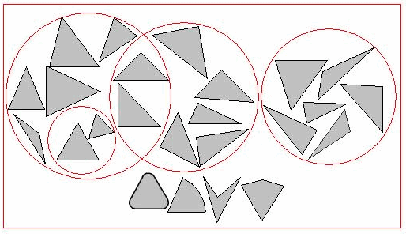
Ode to Math  (A poem, song, dance or drawing) | - Create your own example to share with students.  - Find samples of other people’s work by showing students videos and/or playing songs about math created by others (search TeacherTube)  - Remind students that the purpose of this is for them to focus on what is cool, interesting, and exciting about math, patterns, and beats.  - Give students time to work in class and at home. The next day, have students present their work.  - While individuals present, have the other students complete a presentation rubric or evaluation.  - Have some sort of praise system ready for when a student has completed the presentation (i.e. snap, a “round” of applause, a reaffirming chant). | - The emphasis on this assignment is not math correctness, but instead, building a relationship and inspiring with math.  - Focus on highlighting what students like and appreciate about math.  - You may want to show students a short film like Donald Duck in Mathmagic Land or Between the Folds (both available online for free), or read them an excerpt from a book like The Number Devil.  - This is your opportunity to teach students how to actively listen, respond, and respect presenters. As the teacher, your outcome is for them to learn the procedure while learning about each other.  - Use a website like http://rubistar.4teachers.org/ to help you make a rubric specific to your class.  - If you have time before assigning the Ode to Math, have the students develop the grading criteria with you. Put the students’ input into your rubric that they will use the next day.
My Math Timeline | - Create and show students an example of a timeline about your summer, last school year, or a special time in your life.  - Create and show students your math time line (include when you learned basic arithmetic, high school and college courses, highlights (projects/ field trips), and low points (failed exam/ course).  - Give students paper with a line on it, or provide them with rulers and paper.  - Prepare a list of classroom jobs or group roles that students must follow when working in groups or using supplies.  - Examples of group roles:  - Materials Manager – counts and collects materials  - Time Keeper – tracks time  - Runner – the group member who is allowed to get up from seat to get/ return materials  - Leader – helps other members, raises hand for questions | - Ask students to think about how you decided what to put on your timeline (important events, successes, failures), and what type of events would need to go on a math timeline  - Before you do this activity, you must have all of your supplies and equipment in order. Putting numbers on things and stating the amount of items you put out (i.e. there are 10 packs of markers, and 3 glue sticks out there) informs students that you keep track of things and expect them to all be returned.  - This is your chance to let students know that everyone is responsible for equipment. Without respect and order, fun assignments cannot be done as easily.

